VAISHNAVI E 231901059
EXERCISE 5B
Stack based buffer overflow attacks

Aim: To understand and exploit stack-based buffer overflows by overwriting memory beyond a buffer’s limit.
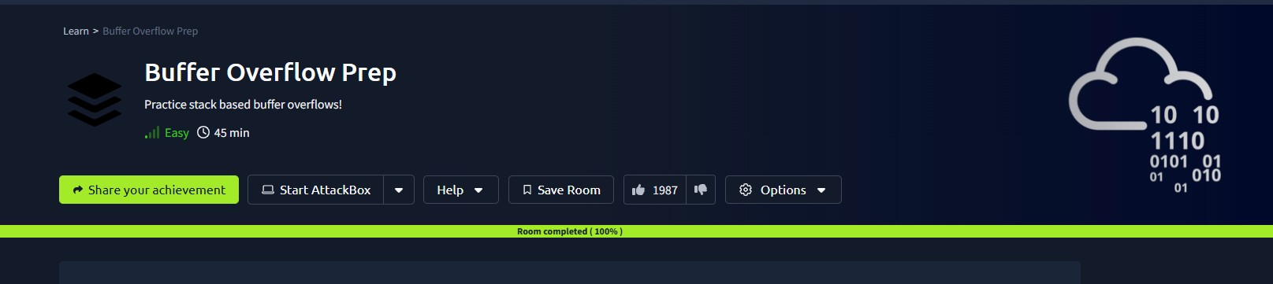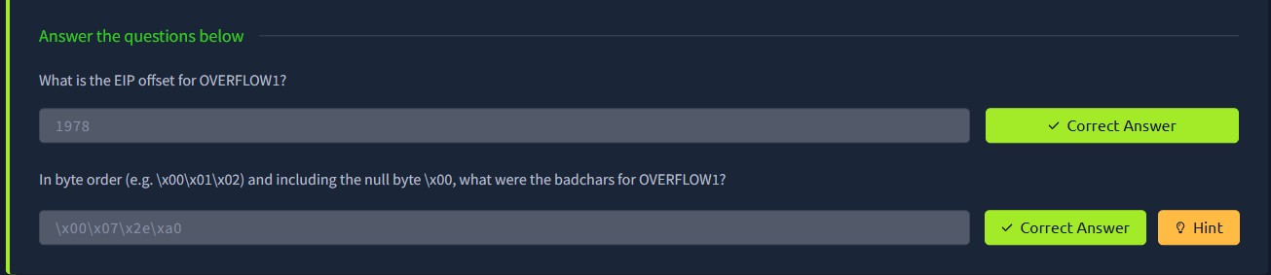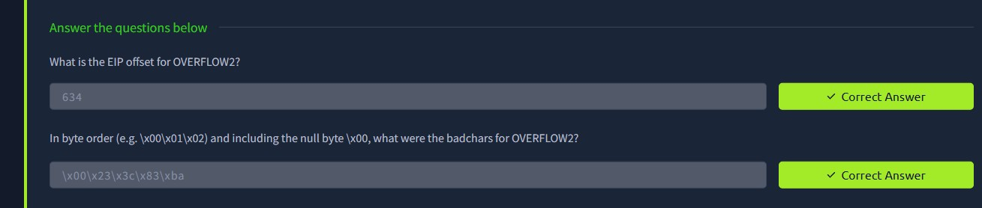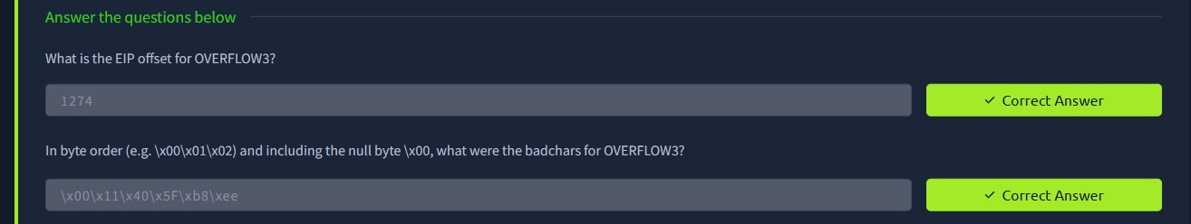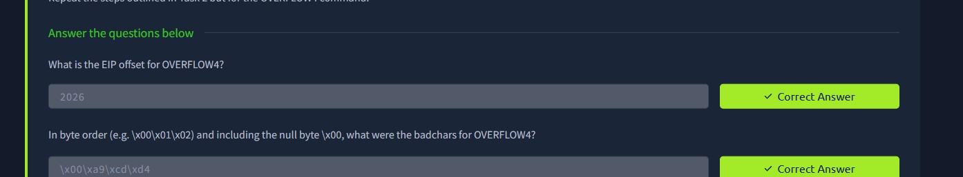
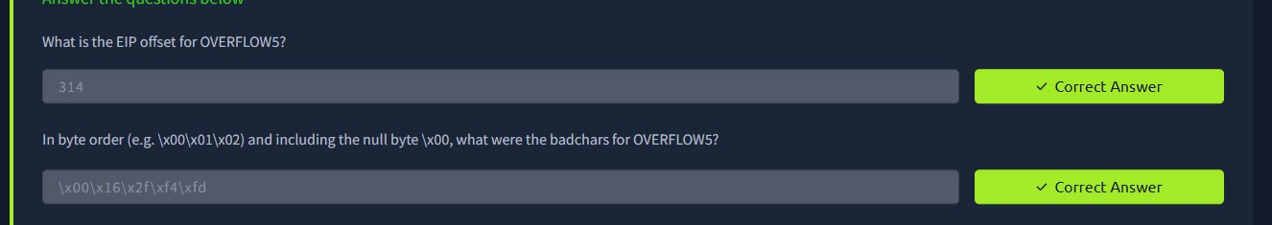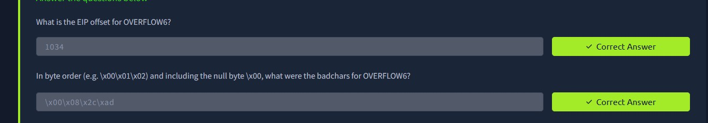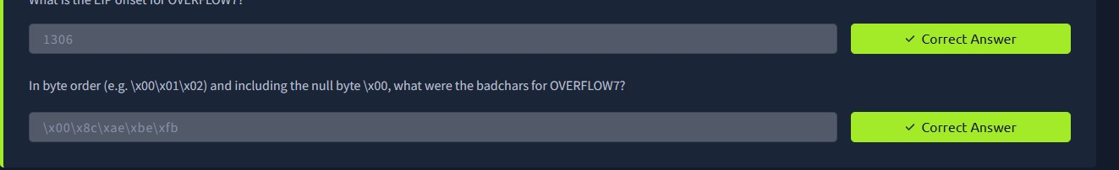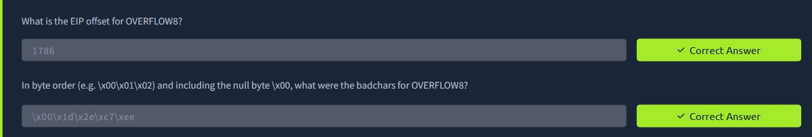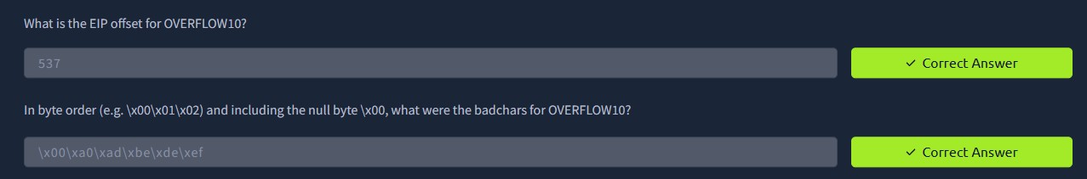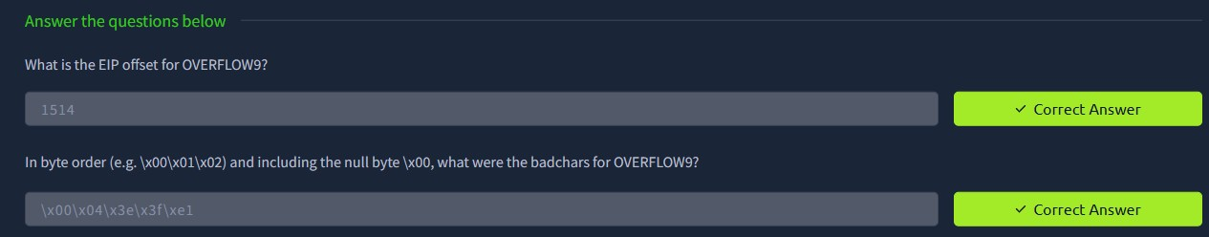

Result: Successfully exploited the buffer overflow to overwrite the return address and redirect program execution.

